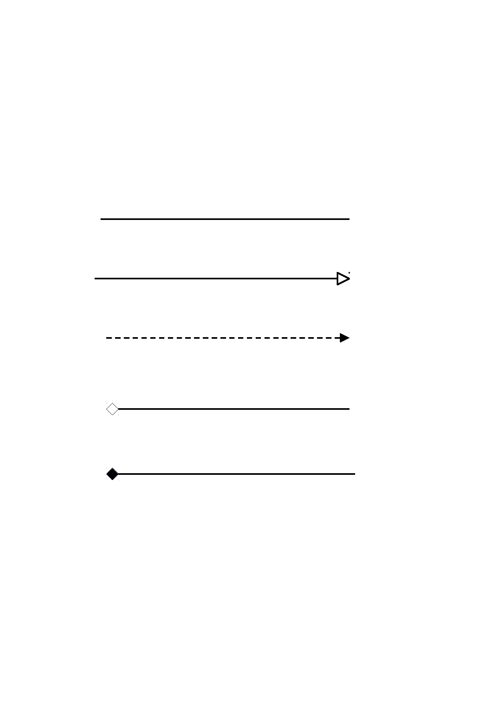
Relationship between classes in UML

Association

Inheritance

Realisation

Aggregation

Composition

